Macintosh HD:Users:carlynkane:Downloads:MAKERS (5).pdfCarlyn Kane

Community, Environment, and Planning Senior Project

Spring 2017

Table of Contents

Abstract/Context……………………….3

Introduction…………………………….4

Literature Review……………………….5

Methodology…………………………..14

Results…………………………………17

Reflection/Conclusion…………………23

Abstract

“Makers” is a podcast series featuring six local female artists answering the basic question “Does art have the power to make political change?” The interviewed artists practice a variety of artistic mediums including theater, music, graphic design, dance, and film. In the podcast, each woman speaks of her experiences as a female artist, of her opinions of the legitimacy of political art, and of her position as a woman in a male-dominated political society. We speak about the strength of storytelling, the power of politicians versus artists, and the vulnerability of artistic expression. The research culminates in a podcast product that acts as inspiration and activism for other women while also providing a platform for artists often silenced or underestimated. The driving intentions of my senior project are to answer personal questions I have about the power of art, to glean wisdom from female artists I respect, and to provide a pertinent podcast for anyone who’s contemplated the potential for art to create social movement.

Context

“Makers” is a project that came to fruition after the most recent Presidential election. In a time where I questioned my ability to react and express my political opinion in any meaningful way, I vowed to get an answer to whether art had the power to create real social movement. As a student studying communities, political science, and dance, an exploration of the intersection between these topics seemed like a valuable process to pursue. As I was having conversations along the lines of this podcast in my day-to-day life, I decided to record the conversations and transform them into a product that could inspire other artists with questions similar to mine. Introduction

“Makers” is an effort to reconcile two parts of my academic and personal self. Merging art and politics, the podcast addresses issues of power and legitimacy in a diverse range of art mediums. Addressing exclusively female artists, I’ve amplified the voices of a group of people who don’t often have platforms to speak unapologetically about their art. I created this project to research whether art is reactionary or inflammatory, if its power lies solely in its individual influence, or if it can succeed in the sphere of a greater social good. The podcast medium has been useful in extending my sphere of possible listeners from the University of Washington, to the Internet beyond. The interviews that inform my project have shaped my identity as an artist and a woman, and my hope is that my project will do for others what it has done for me, inspire and motivate.

Literature Review

I think it would be valuable for me to define social movements prior to defining how art may or may not be a part of them. In Reed’s novel “Art of Protest” his introduction includes a quote from Charles Tilly explaining “the essence of movements entails “repeated public displays” of alternative political and cultural values by a collection of people acting together outside officially sanctioned channels”.[1] Political change can happen as a result of institutionalized change in political parties and lobbyists, and/or in conjunction with social movements that operate outside the sphere of political institutions. Art is deeply rooted in culture, culture dictates social movements, and social movements have the power to make change. “Movements are much more than the sum of quantifiable elements. Movements, especially the kind talked about in this book, are deeply transformative experiences for those who take part in them and deeply transformative to those who are, sometimes quite indirectly or subtly but pervasively, shaped by the ideas, feelings, styles, and behaviors emerging from them”.[2] Social movements are not measured in the way institutional change is, therefore it’s hard to identify art and culture as a means of solid political change.

Art provides a valuable platform and community to instigate political and social change. It can be used as a form of political expression, community activism, and personal education. While still valuable for both genders, art can be an especially useful tool for communities of women. “In art practice, women can engage in their artwork to expose ideological constructions by questioning the traditional cultural values and practice that constitute the discourse of a social system and its political, economical, legal, and educational power. Not only does it serve as a valuable form of education, but a powerful means of creative expression.”[3] Elliot Eisner describes art as a form of human education, shaping human consciousness and perception of their environments. “With respect to art and its meaning, I share Dewey’s view that art is a mode of human experience that in principle can be secured whenever an individual interacts with any aspect of the world.” [4] As for community activism, “Howard Gruber argues that art should, above all things, mobilize people for struggle. To unmask prejudice and secure justice, we need argument, an essential tool of civic freedom.”[5]

Women have been using art as a tool for freedom throughout feminist history; from first wave feminism and the suffragette movement, to second wave feminism and the 60s, to third wave feminism in the 90s, to today’s post-inaugural women’s march. In each movement I will pinpoint one example of art utilized as a tool for freedom.

In the suffragette movement, cartoons for political magazines became a form of art that expressed women’s political stances. The foundation of art schools in the early 19th century provided women’s art the platform to become more political. In New York City, specifically the East Village, women had the opportunity to express their politics through political cartoons written for progressive socialist publications.[6] Lou Rogers, one cartoonist famous from the early 20th century says, “It is not art as art that I am interested in…It’s art as a chance to help women see their own problems, help bring out the things that are true in the traditions that have bound them; help show up the things that are false”.[7]

The second-wave feminist movement of the 60s utilized poetry as a means of sharing experiences and uniting women around common issues. Second wave feminism, unlike first wave feminism, focused more on sexuality, family, the workplace, reproductive rights, and domestic violence. One large pitfall of the second wave feminist movement is its lack of intersectionality between race and experience, leading it to be widely considered “white feminism”. [8] Famous poets like Audre Lorde, Maya Angelou, and Adrienne Rich, wrote poetry to acknowledge their experiences and identities as women. Audre Lorde identified as “a Black feminist, lesbian, poet, mother, and warrior” who used her story to highlight issues of oppressed peoples.[9] She saw the presence of poetry as a necessity for the progress of feminism. Lorde writes about the necessity of poetry in her essay “Poetry Is Not a Luxury”. “They surface in our dreams, and it is our dreams that point the way to freedom. Those dreams are made realizable through our poems that give us the strength and courage to see, to feel, to speak, and to dare. If what we need to dream, to move our spirits most deeply and directly toward and through promise, is discounted as a luxury, then we give up the core-the fountain-of our power, our womanness; we give up the future of our worlds”.[10] To Lorde, art, poetry, is vital to political change, as it is a reflection of our hopes and dreams and a guiding light towards social change.

Third-wave feminism utilized the punk scene of music and zines to mobilize communities of women towards reclaiming power in and outside of the music scene. “To be a girl in 1990s America meant being fed on media lies that to be acceptable you must be impossibly thin and as pretty as a photo-shopped picture. The official line is that you have equality with boys, yet your reproductive rights are being eroded. You have a high chance of being raped, sexually harassed or sexually abused, and a very low chance that any perpetrator gets convicted, and you’ll be told you deserved it anyway because of what you wore or where you went”.[11] Third wave feminism encountered some of the same issues as second wave feminism, yet took on more inclusive and multi-vocal tactics.[12] Third-wavers examined their media driven world more than ever before, performing in-depth critiques on mainstream male-driven culture.[13] In the early 1990s, a group of girls got together in Olympia, Washington and created a “revolution, girl-style” punk band called “bikini kill” and a zine called riot grrrl that set of a chain of punk girl activism around the nation.[14] “Riot grrrl provides a tangible example of a moment when girls and young women visibly created feminist music, writing, and art on their own terms. However, fundamentally it is about the power of young women, girls, and queers who find a way to use music, politics, and punk to transform their local communities now”.[15] Girl punk and zines embodied a movement towards equality, provided an opportunity for women to find solace in each other’s experience, but most importantly took power from a male-dominated media industry and placed it in the hands of women.

Feminist art through the ages shows us the importance of shared experience, a concept known as “consciousness-raising” in the women’s liberation movement. “Feminist consciousness-raising in the late 1960s involved women meeting in small discussion/action groups to share their personal experiences in order to turn them into analyses of common political and structural sources of inequality for women”.[16] Consciousness-raising is deeply connected to my goals for this project, as the purpose of exposing the personal experiences of women’s art is to inspire others to be political in their art making. While my project is virtual rather than in person, the idea is to share personal experiences in order to strengthen sources and inspirations. Putting this “consciousness-raising” online means that more people have the ability to join in.

Storytelling is a hugely important strategy in persuading people to listen to you, follow you, and most importantly, act with you, which is why it is fundamental in social movements. Communication that is interesting is more likely to hook people into interacting with a cause. In the Harvard Business Review, Fryer expresses the importance of storytelling in business interactions. Appealing to people’s emotions is undeniable, there is not arguing with a story like there might be with broad statements and statistics. People are not “inspired to act by reason alone”, storytelling is much more persuasive.[17] In an article by TED talks, Aspen Baker explains the vital importance of sharing experiences in social movements, specifically in the debate of abortion. “Great social movements often have one thing in common: they are created by people with the courage to talk openly about their lives and experiences. Women have sparked movements to end street harassment, generating new public dialogue about safety and respect”.[18] Storytelling and personal expression is key in starting important dialogues that lead to social and political change.

My project utilizes the medium of podcasting as a form of storytelling. Podcasts can be a very effective product for sharing information in our modern and techy society. They can be effective, portable, and intimate ways of summing up the important parts of an argument. Some reasons the learning times lists for utilizing podcasts are that they “make information personal, are convenient and easy to consume, cut costs, are time efficient, portable, on-demand, and easy deliverables for social-networking technology.”[19] Digital Trends lists some steps I should take in creating a well-informed and high-quality podcast. These steps are, “pick a theme, decide an episode format, decide length and script, make a game plan for equipment, and distribute on social media.” [20]

In an attempt to learn even more about the podcast format, I’ve listened to a variety of shows. The show I’ve found to be closest to the format of exposition I am planning on is a hit show, *This American Life*, narrated by Ira Glass, and produced by WBEZ. It is similar to my podcast in that it exposes the stories of individuals surrounding one specific theme. *This American Life*’spurpose is to tell the stories of American lives, to reveal unexpected stories and connect even the most unlikely characters. The show is broken into multiple acts, with stories told as “first-person narratives”.[21] This American Life’s website describes its show as “applying the tools of journalism to everyday lives, personal lives. It’s also true that the journalism we do tends to use a lot of the techniques of fiction: scenes and characters and narrative threads.”[22]

My project will be similar to *This American Life* in its utilization of various narratives to weave together an answer to one general theme: women, art, and politics. I’ve chosen to interview a diverse number of women with various backgrounds, art mediums, and interests.

Before I list the questions I plan to ask my interviewees, I think it’s important to perform some analysis or categorization of a couple pieces of art that I’ve interacted with that has been inspired by or has made a statement on current events and politics. I think this is an important piece of my review, as it is these pieces that have inspired the questions I’ve written.

The first piece of art that pushed me to ask questions around identity and politics is Solange Knowles’ album “A Seat at the Table”. The album is rich in expressions of identity, issues of race and gender, as well as explorations of equality. With a mixture of personal vignettes and inspiring lyrics, Solange weaves together an album that touches listeners in a way most R&B albums cannot manage. The album is so revolutionary that it has been turned into a course offering by the Wake Forest University. The syllabus is titled “A Seat at the Table Syllabus: The Truths of Young Women of Color”.[23] “Solange Knowles’s *A Seat at the Table* has been one of the most reflective and popular albums produced by a young black woman that speaks to issues of race, womanhood, and equality”.[24] The syllabus asks for students to collect “texts, music, and visual art that speak to our experiences” and expresses a deep political emphasis, “If we are to have a democracy in which all of us have a seat at the table, we know that these experiences should be central to the development of America’s practices and policies”. [25] This album acts as a call to action on enacting democracy in America. It’s deeply personal, with clips of Solange’s various family members detailing their experiences with race and childhood. It is hugely moving and political, and stems from the same storytelling concepts that I’ve reviewed early in my literature review.

Another interaction I’ve had is with Natasha Marin, a local writer and poet in Seattle. She utilizes storytelling and expression in her Red Lineage poetry project that involves participants telling the stories of their “lineage”. “When performed, these poems echo and overlap, thereby fostering a sense of community despite real and/or perceived social and demographic barriers”.[26] This poetry is deeply political in its ability to unite communities despite societal differences.

**A small list of other pieces of art I’ve found inspiring and deeply political include:**

-Moonlight, film, 2016

-Jessica Lang, Thousand Yard Stare, dance

-Unpresidented Gestures, dance demonstration, 2016

**“But to argue that poems are every bit as dramatic as these demonstrations, or as confrontations with police, is to make a feminist: what counts as dramatic has often been defined in limiting ways based on male-centered visions of heroic performance”[27]**

Methodology

To answer my research question “Can art create social movement?” I’ve gathered data through interviewing six female artists and turning their interviews into a podcast series. In the following I will explain my processes of interviewing, which women I have interviewed, and how I’ve gathered those clips into a podcast series.

As this project was a deeply personal exploration, I chose to talk to women I know personally as friends, peers, and teachers. I chose to speak only to women as an effort to fulfill one of the goals of this project, offering a legitimate platform for women to talk about their art. I contacted women from a variety of fields including dance, visual art, music, theater, and film. In an effort to create a pool of relatively diverse artists, I paid special attention to speak with both ethnically and artistically diverse women. The women I spoke to, beyond being close friends, have made work that I’ve seen to be inherently political.

After choosing potential interviewees, I began the process of contacting them. I proposed the project to them and asked if they would be willing to be recorded. Every person I contacted was excited and willing to participate in the project. We set up dates and times, and met up at convenient spots, on campus, at homes, even once in a car. I rented a Samson Microphone from the UW equipment rental and set it up for each interview.

The process began with me showing them a list of proposed questions, giving them time to think about potential answers, and pressing record. The interviews themselves were extremely informal. They took place in the context of a conversation rather than a one-sided interview. I worked hard to create a comfortable environment for interviewees so that they would expand on their answers to my questions. Engaging the participants in conversation allowed for the women to understand my reasoning for asking the questions I asked, as well as the direction I wanted to guide them towards. Each answer was informed by their experiences as artists, a point that clearly differentiated the interview answers from each other. I started by asking each artist to give a brief autobiography, “Who are you? Why do you make art? What do you care about?” Then I usually asked them about specific projects, enticing them to give me some information about the work that they create. After giving the future listeners context on the interviewees, we delved into the questions I had written beforehand.

Some of the questions I asked of the women were:

1. Does **art** have the power to catalyze political change?

2. Is art reactionary or inflammatory?

3. Why do you make your art?

4. Does your art act as a form of political therapy for you? Do you make it to be therapy for others?

5. Why do you think people want to interact with art? Is it therapy? Inspiration?

6. Is your art a protest? Can it be? Have you seen art that is effective protest?

7. Is an artist as powerful as a politician?

8. Do you have advice for an artist who feels illegitimate in the political work they’re creating?

After each interview I performed a small debrief on what it felt like to be interviewed, whether they had any hesitations about the information they had espoused, and whether they found the project to be a worthwhile exploration.

When I had completed all six interviews of the women, I began the post-production editing process. I asked each interviewee to send me a song they felt connected to so that I could add it to the intro and outro of each episode. I also asked that they send me clips of audio from their works, whether that be a clip of music from a dance piece, a read poem, or a recorded song. After collecting all the elements necessary to create an episode, I would sit down and listen to the interview in its entirety. I split up the questions and labeled the answers as fit. I also took this time to remove any lengthy clips of me talking about my beliefs or personal answers. I edited the flow together to create a narrative that would be interesting to a potential audience. My final step was to insert the music and sound clips, as well as my voice as a narrative to sew the answers together. Each episode varies in its length, but the average length of an episode is around twenty minutes.

When I finished every episode of Makers, I downloaded those episodes to soundcloud.com, and created a website to feature each episode. The online nature of the podcast makes it very simple for me to distribute the materials to a wide array of audiences. Not only do random listeners on the web get access to these episodes, the links can be sent directly to chosen listeners.

Results

The product of this project is two-fold and split along the lines of the measurable and the immeasurable. As planned, I created a podcast series with seven episodes. I interviewed six female artists that worked in a range of artistic mediums and created an explorative audio experience. Additionally, Makers catalyzed an unseen emotional impact on the participants involved. Makers explored the ability for art to create change, and in that exploration, it was creating the change it sought to explore. Already the podcast has inspired me, and the women I interviewed. I believe that it is a product that has the power to continue creating change and sparking conversation.

Below I give a specific breakdown of the content of each episode; I introduce the artist and give an idea of the topics the episode addresses.

Makers website is at [www.makerspodcast.weebly.com](http://www.makerspodcast.weebly.com). Episodes can be accessed directly by clicking on the photos of the featured artists.

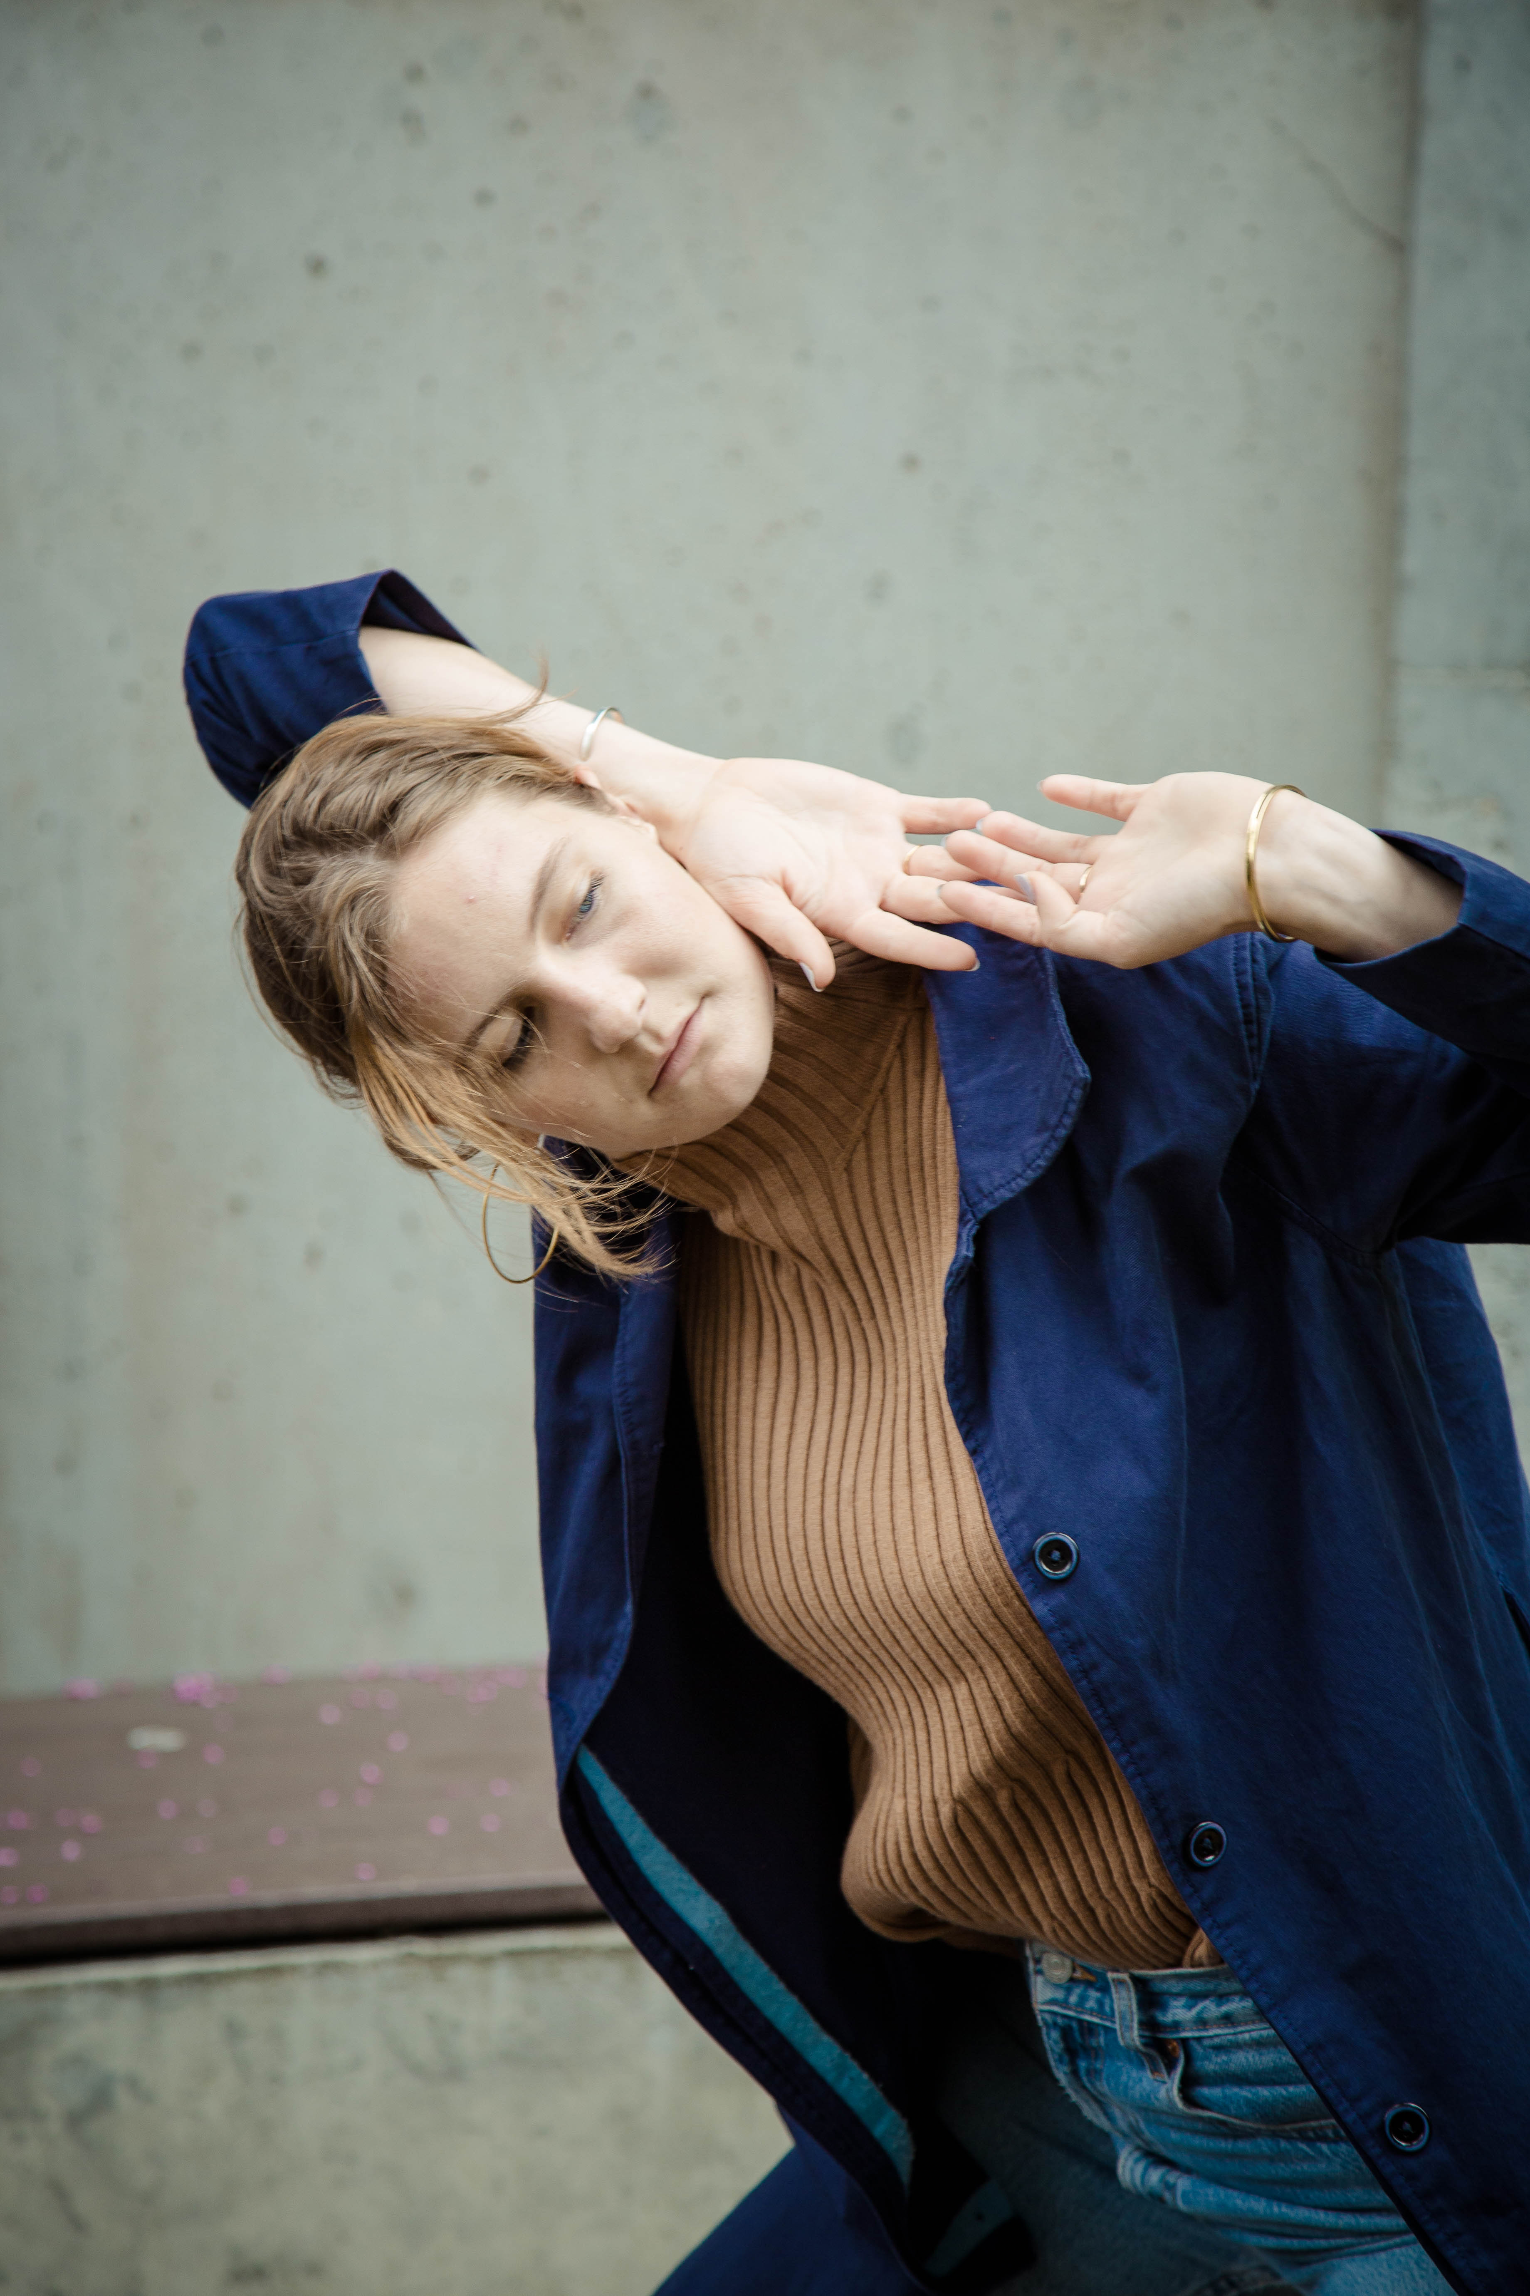

Episode 1: Carlyn Kane (8:49)

To start off the podcast series “Makers”, I created an episode to explain why I created this project. I speak about my identity as an artist, and ask myself the questions I’ve asked my interviewees. I speak on what I’ve learned and what I hope that listeners will take from the series. The episode ends with a “Thank you for listening” and an acknowledgement towards my mentor.

https://soundcloud.com/user-849627111/makers-episode-1

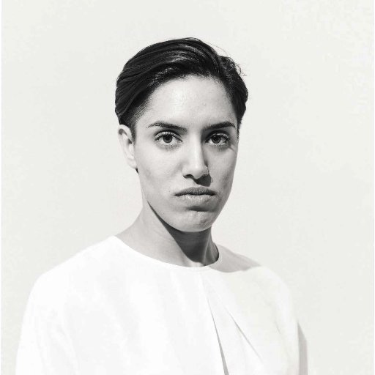

Episode 2: Jasmmine Ramgotra (21:27)

Jasmmine’s episode addresses her experiences as a dancer and a choreographer in answering the question of what makes art political. As a student at the UW she’s made work about issues of climate change, race identity, and what it’s like to be a woman. We speak about how her work has changed and the conversations it has sparked.

https://soundcloud.com/user-849627111/makers-episode-2

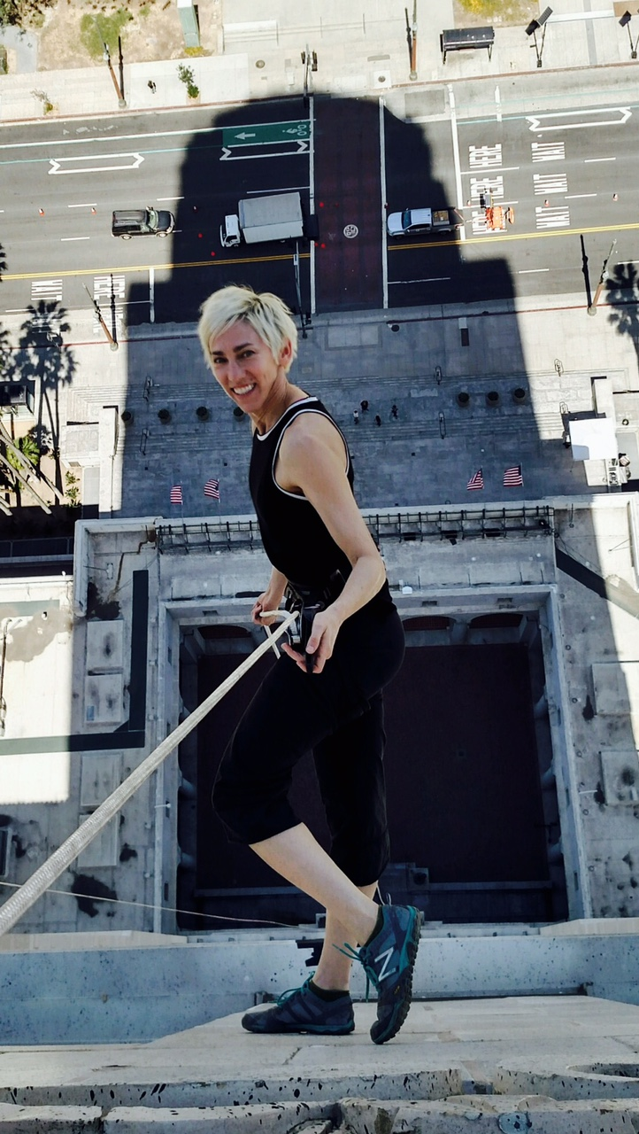

Episode 3: Rachael Lincoln (23:18)

Rachael’s episode is special to me because she is my mentor for this project, as well as being one of my favorite dance professors. As a professional dancer, improviser, and teacher, Rachael has a unique perspective on the questions I’ve asked her. This episode addresses the recent election and the way that she’s has used dance as a tool for personal and community therapy. We talk about the political nature of improvised dance, of her feelings towards purely political dance, and the advice she would offer an artist who’s felt motivated to create social change through art.

https://soundcloud.com/user-849627111/makers-episode-3

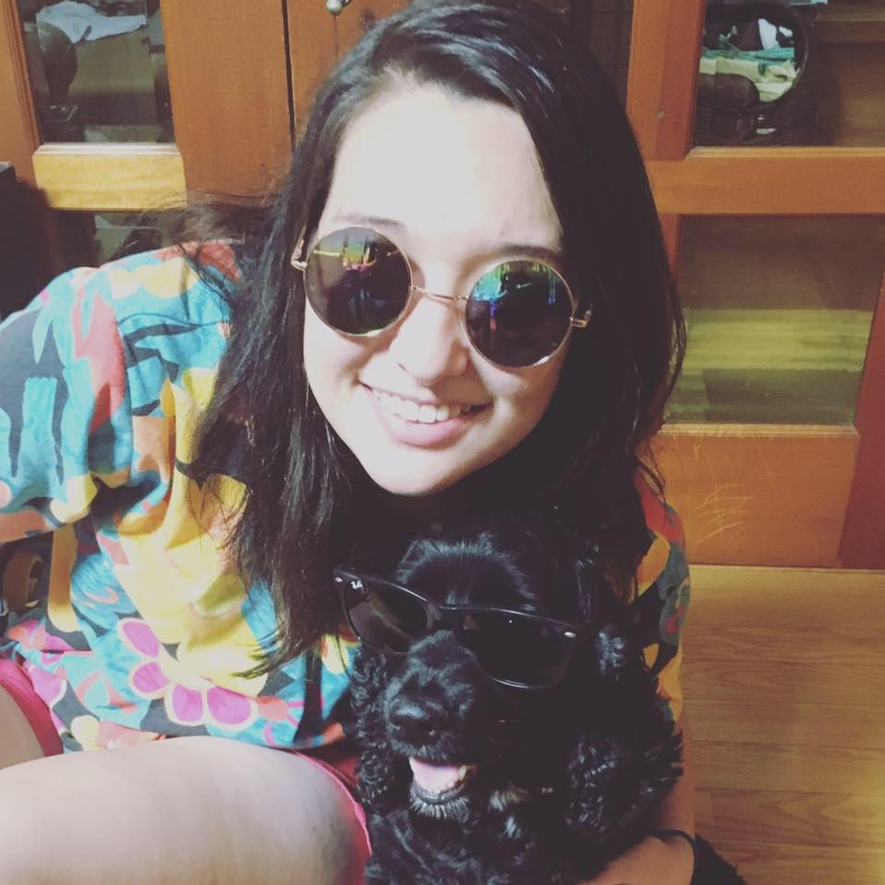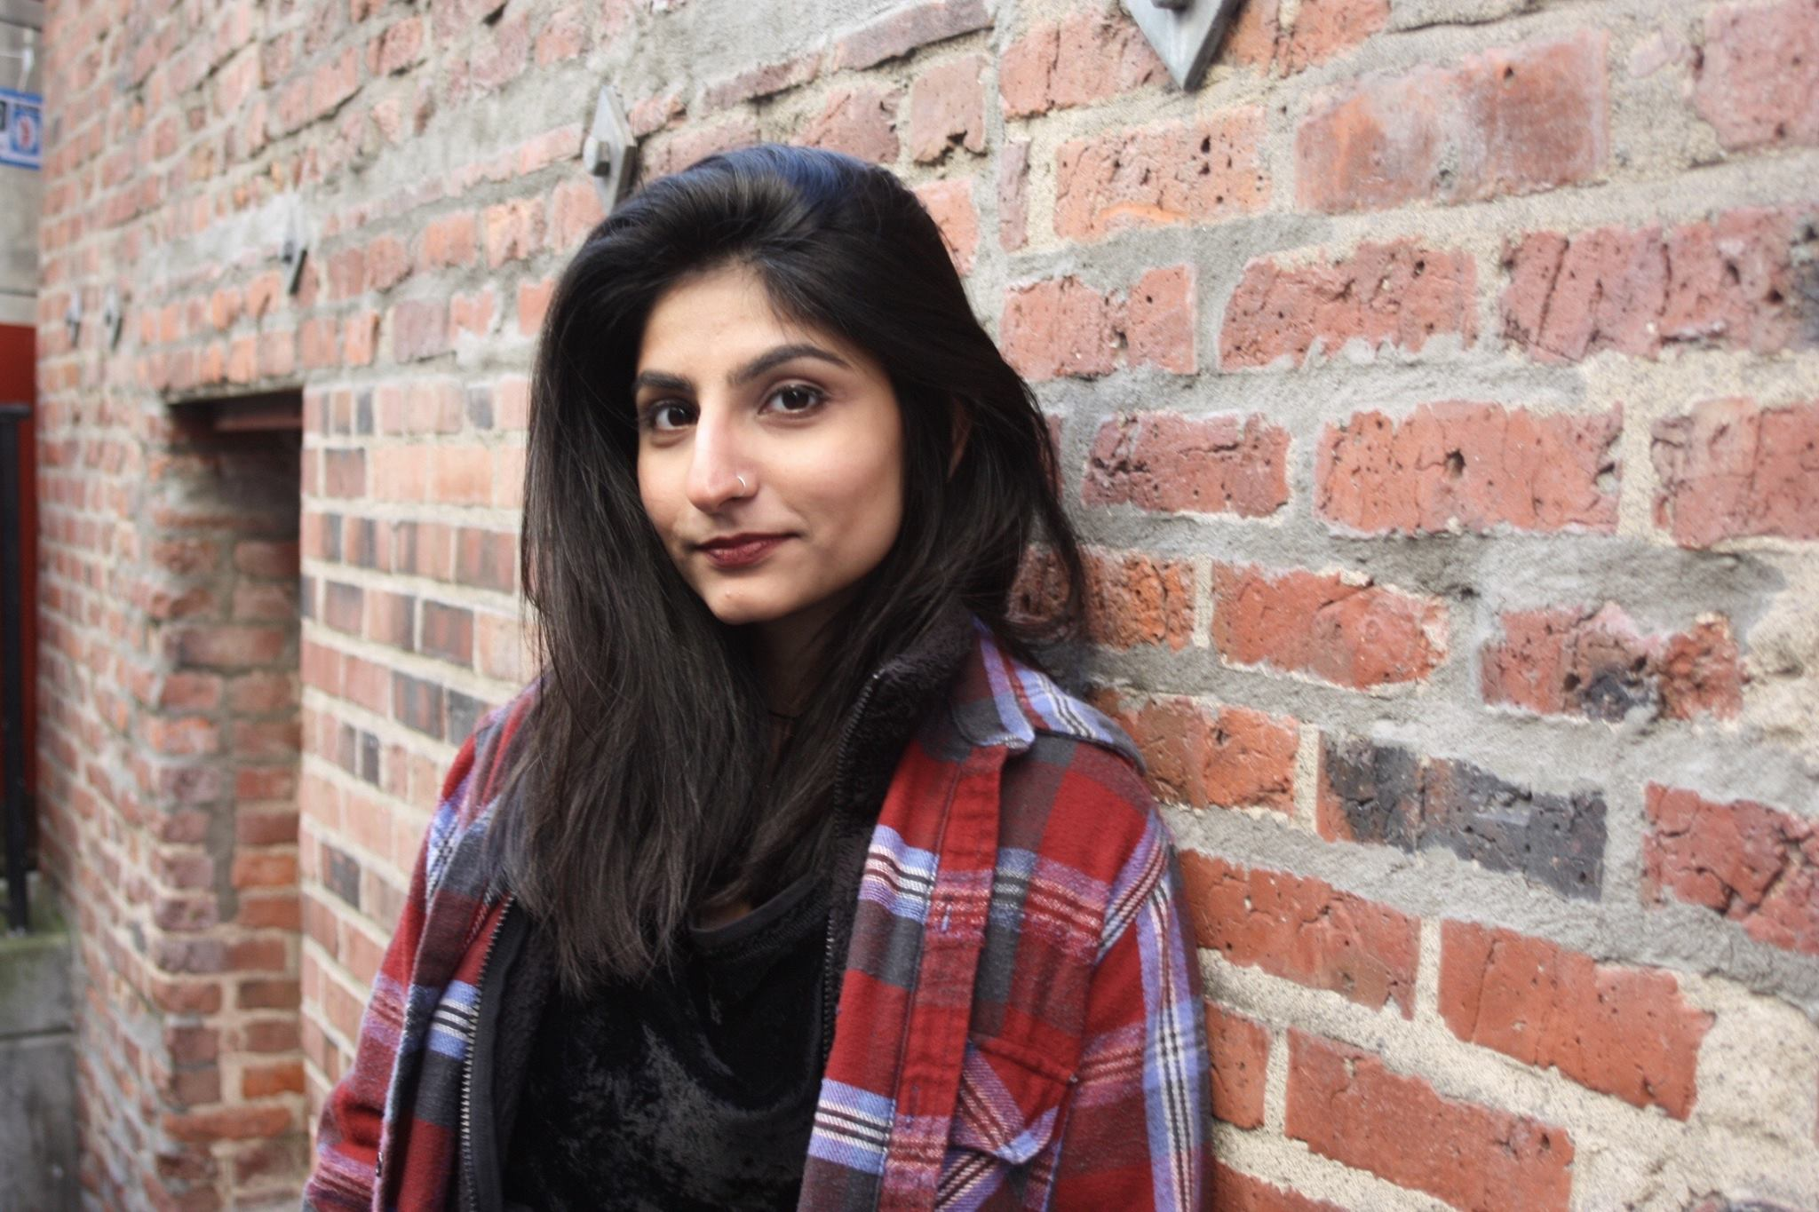

Episode 5: Felicia Alumbaugh (25:27)

Felicia is a filmmaker who studied Cinema Studies at the UW. She is deeply engrained in the Seattle film community, working concessions at various independent film houses and teaching film to children. She also works on her own projects, collaborating with various artists in her field. In this episode we talk about film as a form of space, debate who gets access to that space, and speak on current film inspirations to Felicia today.

https://soundcloud.com/user-849627111/makers-episode-6

Episode 5: Andrea Candelaria (32:35)

Andrea is a painter, actress, musician, and graphic designer currently living in Rochester, New York. In this episode we speak about her use of graphic design to promote political activities on her college campus, as well as the way her music acts as a personal therapy. Andrea references art that she’s found to be inherently political and we explore the reasons behind it. This episode also features a full-length original song by Andrea.

https://soundcloud.com/user-849627111/makers-episode-5

Episode 4: Jeevika Verma (28:35)

Jeevika is a writer, a journalist and a poet. This episode speaks of her experiences as an international student from India, the pressure she feels to study something that will provide her with a post-graduate job, and the privilege she has in being able to pursue her literary dreams. We talk about the power of storytelling and the unavoidable presence of art in our everyday lives.

https://soundcloud.com/user-849627111/makers-episode-4

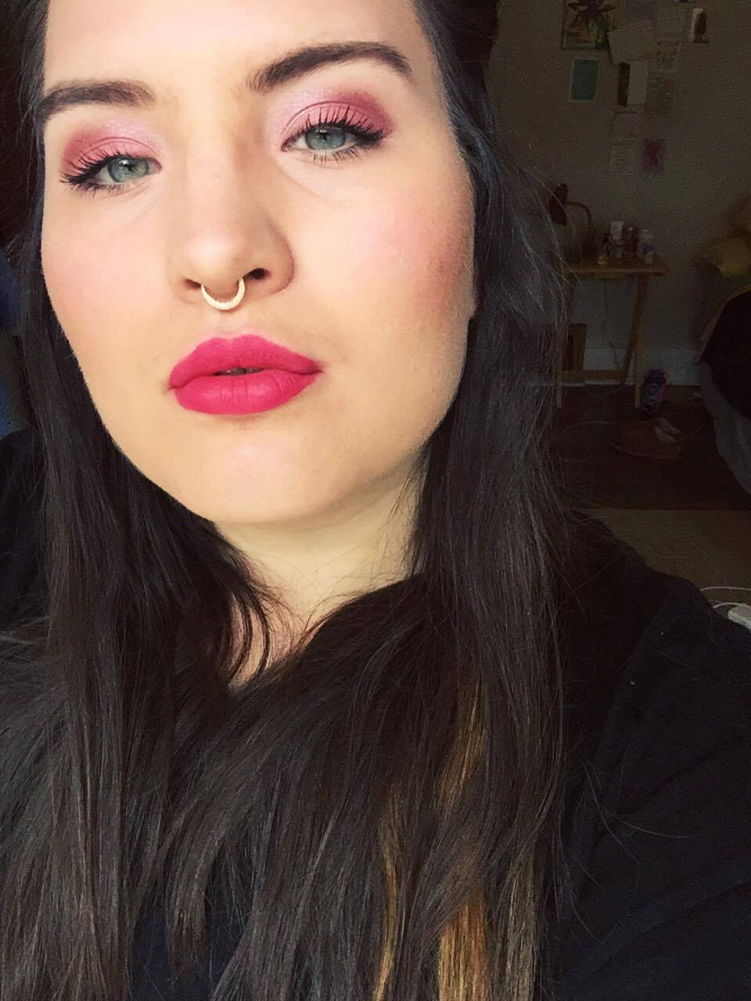

Episode 7: Mairin Hackett (29:33)

Mairin Hackett works as a makeup artist and costumer in the UW theater department. This episode explores the power of identity expression through physical transformation. We talk about costuming as an art form, as well as its power in relation to gender and societal norms.

https://soundcloud.com/user-849627111/makers-episode-7

As one of the primary intentions of Makers was to answer questions I had through interviews, I will explain the general consensus of answers gathered from my processes. Below I will address each question that I asked the interviewees. I will respond with the conglomerate answers that I found.

1. Does **art** have the power to catalyze political change?

Yes art does have the power to catalyze political change, but maybe not directly. There’s no way to measure whether a piece of art directly influence the political outcomes of an individual. Art can make people feel closer to matters they had no exposure to previously, and this can cause big changes in people’s minds and hearts.

1. Is art reactionary or inflammatory?

Art is both reactionary and inflammatory. Art does not exist in a vacuum devoid of the outside world. It takes from what is generally experienced and builds off of it. It reacts, but it also converts its reaction into something that can be inflammatory to its audiences.

1. Why do you make your art?

The interviewees made their art mostly for the joy of creating work. People want to create work that they care about first and foremost so that when they share it, it is honest and noteworthy. Generally people find that the audience’s enjoyment of the art is a positive addition.

1. Does your art act as a form of political therapy for you? Do you make it to be therapy for others?

Sometimes art it is a political therapy, but most typically art acts as a personal therapy. If the political world is affecting an artist personally, they are more likely to react to it in their own art. The recent election has been a catalyst for art making with the artists I interviewed.

1. Why do you think people want to interact with art? Is it therapy? Inspiration?

Because art is beautiful and engaging people are interested in interacting with it. It performs many functions to humanity; therapy, inspiration, protest, and self-reflection are just a few.

1. Is your art a protest? Can it be? Have you seen art that is effective protest?

Most of the artists I interviewed told me that their art was not a protest. Many told me that they wish it could be, and that they believed they interacted with art that was a protest. One woman said that the act of making art is a protest because it is an action that often goes unrewarded by American society. Art can be protest in the very presence of its difficulty to survive on.

1. Is an artist as powerful as a politician?

Perhaps an artist is as powerful as a politician, but the power operates in a different channel. An artist has power that lies in emotions, in beauty, in spheres that are almost impossible to measure. Even though we can’t put numbers on it, it exists. It is power omnipresent than the power a politician has. In fact, politicians are often wielding the power of art to gain power.

8. Do you have advice for an artist who feels illegitimate in the political work they’re creating?

This answer was different for each woman. One woman told me to keep making art regardless of how difficult it may get; that money and resources would figure themselves out as long as an artist learned to persevere. Another woman told me that an artist should follow their passions, that if their love lied in a different, more legitimately political world, that they should pursue that path instead. Another warned to not feel intimidated by other artists, or the label that the word artist holds.

Reflection/Conclusion

Makers has taught me many lessons; how to work GarageBand, how to conduct interviews, and most importantly, how to consider art from an activist standpoint. The act of contacting and interviewing women was probably the easiest thing I learned in this process. The women I contacted were excited about getting involved, and the questions I needed to ask came to very easily to me. The process of interviewing was a bit more complicated than expected, as it was technologically confusing, but also a bit embarrassing. The act of recording a conversation adds an unforeseen tension to what would typically be quite simple. The process of editing the episodes was by far the most difficult lesson to learn. I learned quickly that editing is an extremely time intensive and draining activity. I learned how to operate GarageBand as efficiently as possible, and worked for many hours to streamline the interviews to create interesting episodes for listeners.

In terms of lessons learned from interviews, I received many intriguing answers from every interviewee. The most important thing that I took away from this process is that art has power, but it is a different power than the power of political processes. Art moves slowly, the power it has to change culture is almost impossible to measure. Part of the point of this project was to make me feel like the work I was creating as an artist was legitimate, and this project has affirmed that for me; just not in the terms that I believed it would. Art is valuable for much more than its measured power. It is valuable as its own creation. That being said, these interviews showed me that the power of art is that it’s inescapable. Art is all consuming, it is everywhere, and it is the most interesting format to spread information. I’ve learned to value art for its ability to tell a story, for its power of hooking an audience, and its all-together accessibility for activating marginalized communities. I hope to continue this project in the future. My next steps will to expand the website I’ve created for Makers and continue to interview women about art and politics.

Works Cited

"About Us." This American Life. Accessed February 01, 2017. https://www.thisamericanlife.org/about.

Eisner, Elliot W. *The Arts and the Creation of Mind.* New Haven: Yale University Press, 2002.

Evans, Judith. *Feminist theory today: an introduction to second-wave feminism*. London: Sage Publications, 1995.

"How stories of personal experience help drive change." Ideas.ted.com. November 18, 2015. Accessed February 01, 2017. http://ideas.ted.com/how-stories-of-personal-experience-help-drive-change/.

Lorde, Audre. *Poetry is not a luxury*. Osnabrück, Germany: Druck- & Verlagscooperative, 1993.

"Natasha Marin Portfolio." Natasha Marin Portfolio. Accessed February 01, 2017. http://www.natasha-marin.com/red-lineage.

Reed, T. V. *The art of protest: culture and activism from the civil rights movement to the streets of Seattle*. Minneapolis: University of Minnesota Press, 2005.

"Riot grrrl: searching for music's young female revolutionaries." The Guardian. March 18, 2013. Accessed February 01, 2017.

https://www.theguardian.com/music/2013/mar/18/riot-grrrl-music-female-rebels.

Sheppard, Alice. *Cartooning for suffrage*. Albuquerque: University of New Mexico Press, 1993.

Snyder, R. Claire. "What Is Third‐Wave Feminism? A New Directions Essay." *Signs: Journal of Women in Culture and Society* 34, no. 1 (2008): 175-96. doi:10.1086/588436.

"Solange's 'A Seat At The Table' Inspires Course Syllabus For Women Of Colour." Konbini Nigeria. January 30, 2017. Accessed February 01, 2017. http://www.konbini.com/ng/entertainment/solanges-seat-table-inspires-course-syllabus-women-colour/.

"Storytelling That Moves People." Harvard Business Review. July 31, 2014. Accessed February 01, 2017. https://hbr.org/2003/06/storytelling-that-moves-people.

Yun, Suk Nam, and Yong Soon Min. “Art as Political Act: Expression of Cultural Identity, Self-Identity, and Gender.” *Aesthetic Education* 39, no. 3 (2005). Accessed December 6, 2016.

1. Reed, T. V. *The art of protest: culture and activism from the civil rights movement to the streets of Seattle.* Minneapolis: University of Minnesota Press, 2005, xiv.
2. Ibid.
3. Yun, Suk Nam, and Yong Soon Min. “Art as Political Act: Expression of Cultural Identity, Self-Identity, and Gender.” *Aesthetic Education* 39, no. 3 (2005). Accessed December 6, 2016.
4. Eisner, Elliot W. *The Arts and the Creation of Mind.* New Haven: Yale University Press, 2002.
5. Yun, Suk Nam, and Yong Soon Min. “Art as Political Act: Expression of Cultural Identity, Self-Identity, and Gender.” *Aesthetic Education* 39, no. 3 (2005). Accessed December 6, 2016.
6. Sheppard, Alice. *Cartooning for suffrage*. Albuquerque: University of New Mexico Press, 1993.
7. Ibid, 1.
8. Evans, Judith. *Feminist theory today: an introduction to second-wave feminism*. London: Sage Publications, 1995.
9. Ibid.
10. Lorde, Audre. *Poetry is not a luxury*. Osnabrück, Germany: Druck- & Verlagscooperative, 1993.
11. "Riot grrrl: searching for music's young female revolutionaries." The Guardian. March 18, 2013. Accessed February 01, 2017. https://www.theguardian.com/music/2013/mar/18/riot-grrrl-music-female-rebels.
12. Snyder, R. Claire. "What Is Third‐Wave Feminism? A New Directions Essay." *Signs: Journal of Women in Culture and Society* 34, no. 1 (2008): 175-96. doi:10.1086/588436.
13. Ibid.
14. "Riot grrrl: searching for music's young female revolutionaries." The Guardian. March 18, 2013. Accessed February 01, 2017. https://www.theguardian.com/music/2013/mar/18/riot-grrrl-music-female-rebels.
15. Ibid.
16. Reed, T. V. *The art of protest: culture and activism from the civil rights movement to the streets of Seattle.* Minneapolis: University of Minnesota Press, 2005, 72.
17. "Storytelling That Moves People." Harvard Business Review. July 31, 2014. Accessed February 01, 2017. https://hbr.org/2003/06/storytelling-that-moves-people.
18. "How stories of personal experience help drive change." Ideas.ted.com. November 18, 2015. Accessed February 01, 2017. http://ideas.ted.com/how-stories-of-personal-experience-help-drive-change/.
19. "What Is Podcasting?" LearningTimes RSS. Accessed December 06, 2016. <http://www.learningtimes.com/what-we-do/podcast-production/about/>.
20. @Brendan_LH. "How to Make a Successful Podcast." Digital Trends. 2016. Accessed December 06, 2016. http://www.digitaltrends.com/how-to/how-to-make-a-podcast/4/.
21. "About Us." This American Life. Accessed February 01, 2017. https://www.thisamericanlife.org/about.
22. Ibid.
23. "Solange's 'A Seat At The Table' Inspires Course Syllabus For Women Of Colour." Konbini Nigeria. January 30, 2017. Accessed February 01, 2017. http://www.konbini.com/ng/entertainment/solanges-seat-table-inspires-course-syllabus-women-colour/.
24. Ibid.
25. Ibid.
26. "Natasha Marin Portfolio." Natasha Marin Portfolio. Accessed February 01, 2017. http://www.natasha-marin.com/red-lineage.
27. Reed, T. V. *The art of protest: culture and activism from the civil rights movement to the streets of Seattle.* Minneapolis: University of Minnesota Press, 2005, 71.